Table of Contents

Table of Contents . . . . . . . . . . . . . . . . . . . . . . . . . . . . . . . . . . . . . . . . . 2
- Introduction . . . . . . . . . . . . . . . . . . . . . . . . . . . . . . . . . . . . . . . . . . . . . .
  - Purpose
  - Scope
    - Description of the problem
    - Current system
    - Goals
  - Definitions, acronyms and abbreviations
    - Definitions
    - Acronyms
    - Abbreviations
  - Revision history
  - Reference documents
  - Document structure
- Overall Description
  - Product perspective
  - Product functions
  - User characteristics
  - Assumptions, dependencies and constraints

1. Introduction
1.1 Purpose
This is the Requirement Analysis ans Specification Document (RASD).
As defined by the IEEE Standards, the goals of this document are to give a complete description of the system-to-be, in terms of both functional and non-functional requirements, to analyse the needs of the costumer in order to model the system, show the constraints blah blah

1.2 Scope
1.2.1 Definition of the problem
TrackMe is a company that wants to develop a software-based service allowing third parties to monitor the location and health status of individuals. This service is called Data4Help. The service supports the registration of individuals who, by registering, agree that TrackMe acquires their data
(data acquisition can happen through smartwatches or similar devices). Also, it supports the registration of third parties. After registration, these third parties can request:
- Access to the data of some specific individuals(we can assume, for instance, that they know an individual by his/her social security number or fiscal code in Italy). In this case, TrackMe passes the request to the specific individuals who can accept or refuse it.
- Access to anonymized data of groups of individuals (for instance, all those living in a certain geographical area, all those of a specific age range, etc.). These requests are handled directly by TrackMe that approves them if it is able to properly anonymize t he requested data. For instance, if the third party is asking for data about 10-year-old children living in a certain street in Milan and the number of these children is two, then the third party could be able to derive their identity simply having people monitoring the residents of the street between 8.00 and 9.00 when kids go to school. Then, to avoid this risk and the possibility of a misuse of data, TrackMe will not accept the request. For simplicity, we assume that TrackMe will accept any request for which the number of individuals whose data satisfy the request is higher than 1000.

As soon as a request for data is approved, TrackMe makes the previously saved data available to the third party. Also, it allows the third party to subscribe to new data and to receive them as soon as they are produced.

Imagine now that, after some time, TrackMe realizes that a good part of its third-party customers wants to use the data acquired through Data4Help to offer a personalized and non-intrusive SOS service to elderly people. Therefore, TrackMe decides to build a new service, called AutomatedSOS, on top of Data4Help. AutomatedSOS monitors the health status of the subscribed customers and, when such parameters are below certain thresholds, sends to the location of the customer an ambulance, guaranteeing a reaction time of less than 5 seconds from the time the parameters are below the threshold.
1.2.2 Current System
TrackMe has no pre-existing services that need to be integrated with the new ones, Data4Help and AutomatedSOS. The whole system-to-be is going to be build completely from scratch, therefore no current system will be considered during the design process.
1.2.3 Goals
- G1:
- G2:
- G3:
1.3 Definitions, acronyms and abbreviations
1.3.1 Definitions
1.3.2 Acronyms
1.3.3 Abbreviations

- Gn: the goal number n.
- Dn: the domain assumption number n.
- Rn: the functional requirement number n.

1.4 Revision history
At the moment there is no revision history to show, as this current version is the only existent one.

1.5 Reference documents
- Specification document: “Mandatory Project Assignment AY 2018-2019”
- IEEE Std 830-1993 - IEEE Guide to Software Requirements Specifications
- IEEE Std 830-1998 - IEEE Recommended Practice for Software Requirements Specifications

1.6 Document structure
This document is composed by seven main parts, including a final appendix.

- Introduction. In the first part the problem is presented, with all the main basic information needed to fully understand the scope and the objective of the document itself. All the goals of the system-to-be are already specified and explained.
- Overall Description. The second part is a comprehensive general description of the system: there is the presentation of its boundaries and the specification the main actors that will use the system itself.
- Specific Requirements. The third part is a precise specification of the aspects already discussed in the previous section, in order to clarify the details for the development team. There is here an identification of every specific requirement, functional or non-functional. Furthermore, here is the use case diagrams, use cases, performance analysis, design constraints and finally the attributes of the software system.

- Analysis or the System. The fourth part provides a more formal analysis of the system, using both formal and semi-formal approaches (respectively, using Alloy). A more rigorous approach is used to define the critical aspects of the system.
- Appendix. The fifth and last part comprehends a list the tools used to redact this document and its contents and a detailed report of the hours and efforts spent by each member of the group during the project.

2. Overall Description
2.1 Product perspective

2.2 Product functions
2.3 User characteristics
2.4 Assumptions, dependencies and constraints

- Specific Requirements
  - External Interface Requirements (add pictures)
In this section we will specify how the modules of this system will interact the one to each other.
    - User Interfaces
Since the application only gather data about health status and position it only needs to be downloaded from the store, to allow registration of your type (individual or third party), check login credentials and then run in background. If it is a third party request access to data. (page when user can control the tracking permission to each third party)
    - Hardware Interfaces
The hardware component (smartwatches) will be worn every day.
    - Software Interfaces
The core of the system will reside in a central computer (server) which registers the user in the database, allows the safe login, receive updated on a regular basis. There is an interface between the system and third-party enterprises: the incoming requests will be therefore processed then allowed or denied.
    - Communication Interfaces
The connection between the modules employs the Web.
  - Functional Requirements
Here we will define the use case diagrams, use cases and the full state diagrams, the Goal we expect to fulfil, and the mapping on the requirements.
    - Use case diagrams
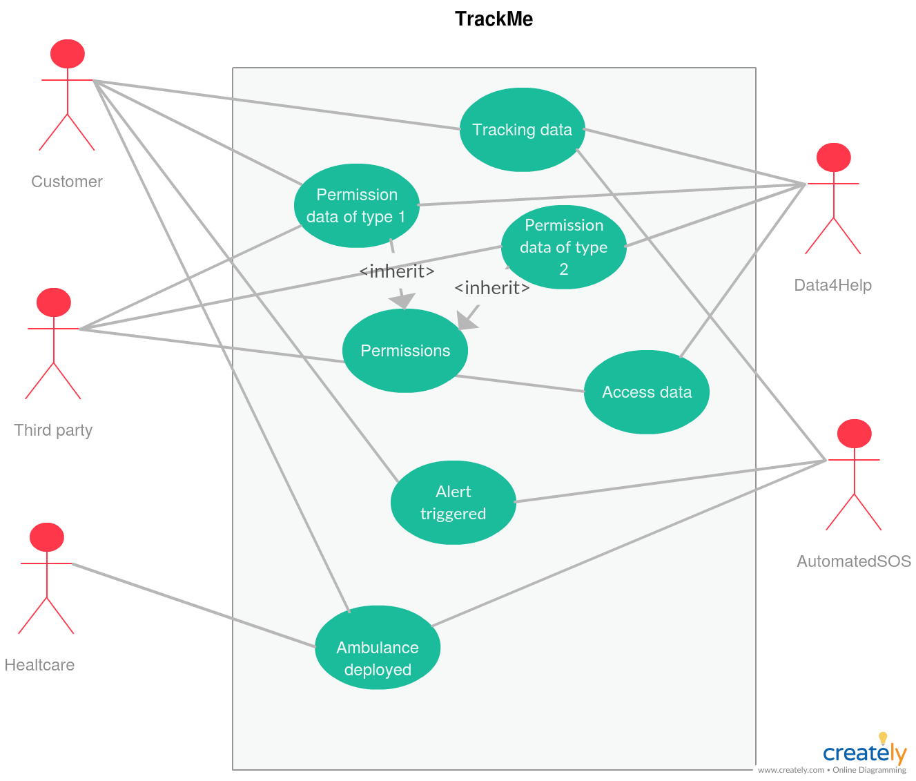
      - General use case diagram
01111

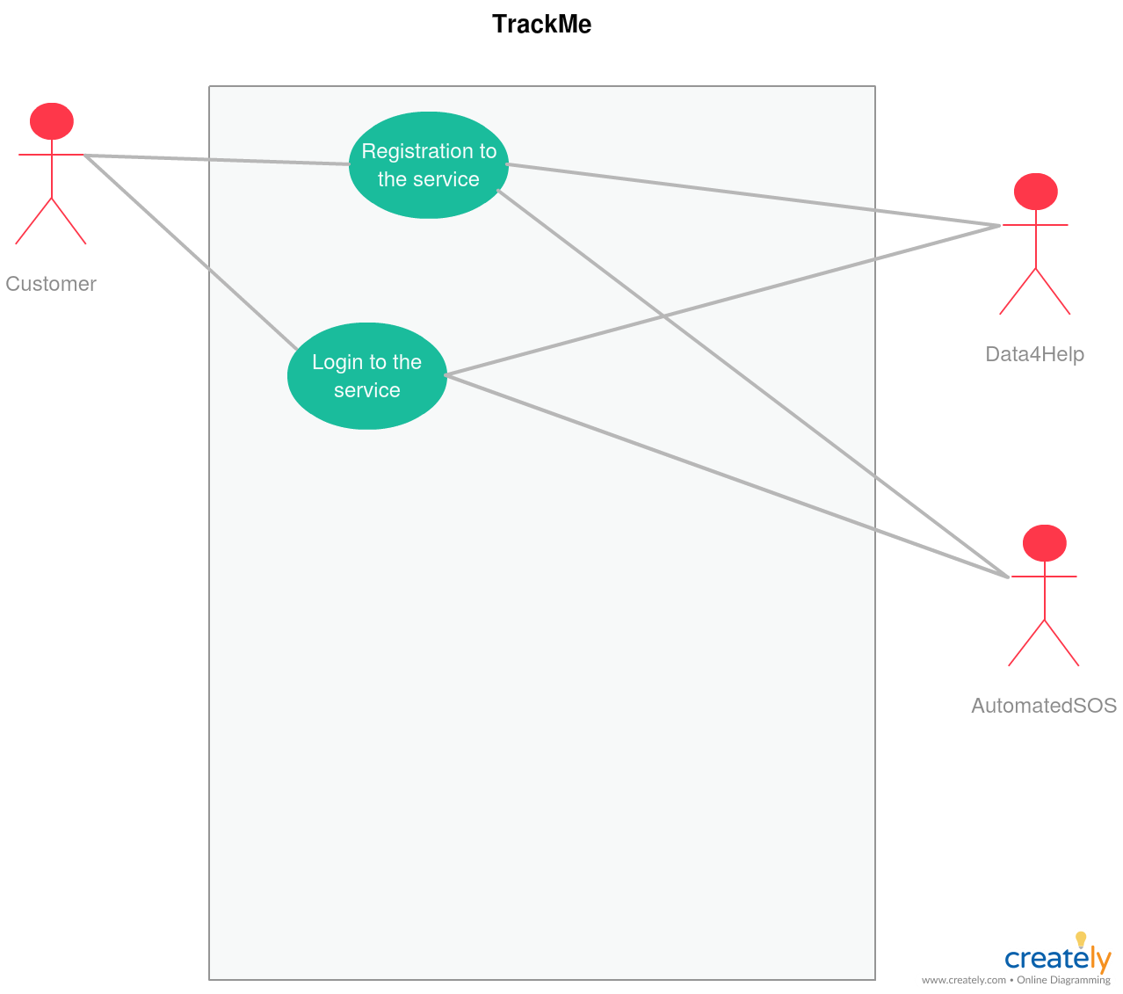
      - User use case diagram

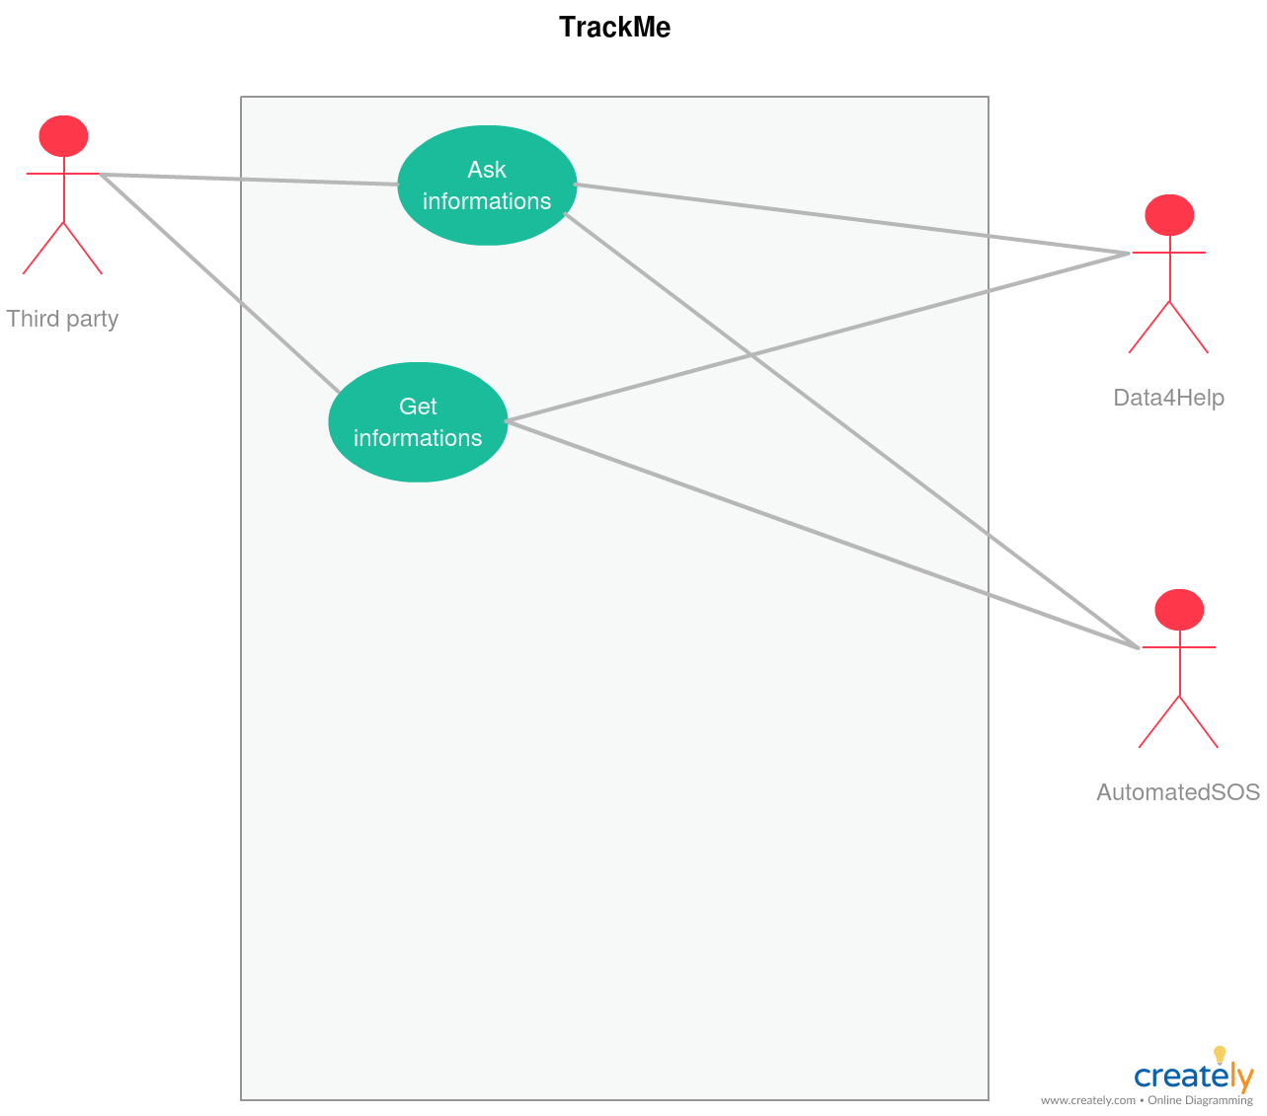
      - Third party use case diagram

    - Proper functional requirements
      - G1. Allow the registration of the user
            - R1
            - R2
            - D1
            - D2
      - G2. Allow the tracking and subsequent storing of data
            - R1
            - R2
            - D1
            - D2
      - G3. Guarantee the data privacy protection
            - R1
            - R2
            - D1
            - D2
      - G4. Allow the registration of the third parties
            - R1
            - R2
            - D1
            - D2
      - G5. Allow the third party to ask users’ data
            - R1
            - R2
            - D1
            - D2
      - G6. The system must be able to promptly detect harmful events
            - R1
            - R2
            - D1
            - D2
      - G7. An ambulance must be deployed within specified time constraint
            - R1
            - R2
            - D1
            - D2
    - Use cases (explain what to do when exceptions occur)
      - Individual registration
ACTORS | Future user
GOALS | G1
INPUT CONDITIONS | -The user is not previously registered
EVENTS FLOW | -The user inserts e-mail and password  -The user clicks on the “Enter” button  -The user clicks on the individual button  -The user inserts its personal data (e.g. fiscal code) which will be validated prior to effective creation of account.
OUTPUT CONDITIONS | -The user is granted service of the application by logging-in
EXCEPTIONS | -Internet connection interrupted  -The user is already registered.  -Password chosen doesn’t fulfil the constraints on it  -User doesn’t follow the link on the confirmation e-mail afterwards
      - User login
ACTORS | Current user
GOALS | G2
INPUT CONDITIONS | The user is already registered
EVENTS FLOW | -The user inserts e-mail and password  -The user clicks enter  -The system detects that the user is already registered  -The app shows the “Stop tracking” button and the notification bar
OUTPUT CONDITIONS | Tracking starts
EXCEPTIONS | -Internet connection interrupted
      - Third party registration
ACTORS | Future third party user
GOALS | G4
INPUT CONDITIONS | -The user is not previously registered
EVENTS FLOW | -The user inserts e-mail and password  -The user clicks on the “Enter” button  -The user clicks on the third-party button  -The user inserts its personal data (e.g. Business number) which will be validated prior to effective creation of account.
OUTPUT CONDITIONS | -The user is granted service of the application by logging-in
EXCEPTIONS | -Internet connection interrupted  -The user is already registered.  -Password chosen doesn’t fulfil the constraints on it  -User doesn’t follow the link on the confirmation e-mail afterwards
      - Third party login
ACTORS | Current user
GOALS | G5
INPUT CONDITIONS | The user is already registered
EVENTS FLOW | -The user inserts e-mail and password  -The user clicks enter  -The system detects that the user is already registered  -The app shows the “Stop tracking” button and the notification bar
OUTPUT CONDITIONS | User can start requesting data
EXCEPTIONS | -Internet connection interrupted
      - App tracking at work
ACTORS | User
GOALS | G2
INPUT CONDITIONS | User successfully logged-in
EVENTS FLOW | No further actions needed here
OUTPUT CONDITIONS | Data being forwarded to the server
EXCEPTIONS | -GPS signal absent  -Sensors not working properly
      - Request to access private data
ACTORS | Third party
GOALS | G5
INPUT CONDITIONS | Third party is logged in
EVENTS FLOW | Third party sends request to the server specifying CF and the type of data he wants to access with “-subscribe” option
OUTPUT CONDITIONS | The request is sent
EXCEPTIONS | -CF does not exist  -Malformed request
      - User permission about the personal data request

ACTORS | User
GOALS | G3
INPUT CONDITIONS | A request to receive data and updates is pending user approval
EVENTS FLOW | -User gets notified about the request  -User open the application, goes to the notification area and approve it or refuse it, considering the “-subscribe” option
OUTPUT CONDITIONS | The request is approved or denied
EXCEPTIONS | No exceptions: in case of connection problems the answer is cached and sent when connection is obtained
      - Request to access generalized data
ACTORS | Third party
GOALS | G5
INPUT CONDITIONS | Third party is logged in
EVENTS FLOW | Third party sends request to the server specifying the number of people () and the type of data he wants to access with “-subscribe” option
OUTPUT CONDITIONS | The request is sent
EXCEPTIONS | -Malformed request
      - System permission about the generalized data request

ACTORS | User
GOALS | G3
INPUT CONDITIONS | A request to receive generalized data and updates is pending system approval
EVENTS FLOW | System automatically approves or refuse request
OUTPUT CONDITIONS | The request is approved or denied
EXCEPTIONS | No exceptions: in case of connection problems the answer is cached and sent when connection is obtained
      - Vital parameters drop below alert threshold and the help-request is triggered
ACTORS | User
GOALS | G6
INPUT CONDITIONS | Actual vital parameters fall
EVENTS FLOW | -The application become aware of the critical situation  -The help-request is sent to the server, providing location of the patient and which parameters have fallen
OUTPUT CONDITIONS | The server processes the request
EXCEPTIONS | -The time constraints are not satisfied  -GPS not working
      - Ambulance deployed when help-request gets the server
ACTORS | Emergency dept.
GOALS | G7
INPUT CONDITIONS | Help-request received from a user
EVENTS FLOW | System elaborate the position of the user and send the position of the user along with the status of the patient
OUTPUT CONDITIONS | The ambulance gets the user within the time constraints
EXCEPTIONS | -High congestion causing delays  -Ambulance involved in car accident  -Technical issues of the ambulance

    - Full state diagram

    - Performance requirements
    - Design constraints
      - Standard compliance
      - Hardware limitations
      - Any other constraints
    - Software system attributes
      - Reliability
      - Availability
      - Security
      - Maintainability
      - Portability

7. Appendix
7.1 Used tools

- OpenOffice Writer
- StarUML
- Microsoft Office 365
- Creately

7.2 Hours of work
7.2.1 Giorgio Polla

DATE | TASK | HOURS

7.2.2. Alberto Tiraboschi
DATE | TASK | HOURS
21/10/2018 | Outline of the chapter | 2
28/10/2018 | Use case diagrams produced, outline of the goals and merge of papers in one file | 6

